📘 PROJECT DOCUMENTATION — Neighborhood Tools Rental Analysis
DATA ANALYSIS & BUSINESS INSIGHTS PROJECT

Project By:
MALLIKA.M
Data Analytics Enthusiast
(Personal Project – 2025 Edition)

Contact Information:
Email: malliksivarao@gmail.com
Phone: 8555986385
Location: Hyderabad

Tools & Technologies Used:
SQL • Python • Pandas • Power BI • Excel • CSV

Project Type:
Independent Personal Project

Date:
November 2025

PROJECT TITLE
NEIGHBORHOOD TOOLS – DATA ANALYSIS & BUSINESS INSIGHTS

PROBLEM STATEMENT
Neighborhood Tools is a tool-rental platform where customers rent tools such as drilling machines, gardening tools, and repair equipment.
The company wants to understand:
- City-wise demand
- Tool performance
- Category & condition analysis
- Customer satisfaction
- Revenue trends
- Operational timelines
- Monthly/Yearly revenue
- Inventory distribution
They want a centralized analytical dashboard to support decision-making.

PROJECT OBJECTIVE
The goal of this project is to:
- Clean raw CSV data using SQL & Python
- Build a star schema model in Power BI
- Create 5 interactive dashboards
- Extract business insights
- Support decisions on inventory, pricing, and customer behavior

DATASET DESCRIPTION
The dataset contains multiple CSV files (users, tools, reservations, reviews, transactions, locations, categories).

Key Tables:
Table Name | Description
users | Customer details
tools | Tool data (title, condition, category)
categories | Category master table
reservations | Reservation/booking data
transactions | Payment & revenue
reviews | User ratings
locations | Cities & Areas
Total cleaned files are included in your zip:
🔗 /mnt/data/neighborhood_tools_SQL_cleaned_final.zip

TOOLS & TECHNOLOGIES USED
Tool | Purpose
SQL | Data extraction, joining, cleaning
Python (Pandas) | Data cleaning, handling nulls, merging
Power BI | Dashboard creation, modeling, DAX measures
Excel / CSV | Dataset storage

ER DIAGRAM – DATA MODEL STRUCTURE
This ER Diagram represents the logical structure of the Neighborhood Tools Rental System.
It defines key business entities such as Users, Tools, Categories, Reservations, Transactions,
Reviews, and Locations, and shows how they are interconnected using primary and foreign keys.
These relationships enable accurate data modeling and efficient joins across the system.
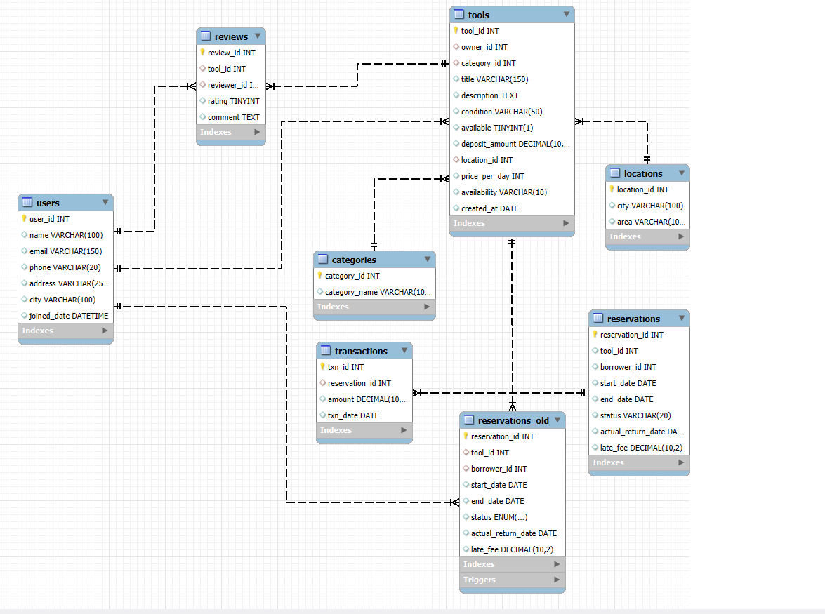

Key Relationships

• Users → Reservations, Reviews, Transactions (1-to-many)
• Tools → Reservations, Reviews (1-to-many)
• Categories → Tools (1-to-many)
• Reservations → Transactions (1-to-many)
• Locations → Users, Tools (1-to-many)

POWER BI DATA MODELLING

Power BI Data Model Overview

This Power BI Model follows a star schema structure with Reservations as the central fact table and Users, Tools, Categories, Locations, Reviews, and Transactions as supporting dimension tables. Single-direction relationships ensure slicers work correctly across dashboards and avoid circular filters.
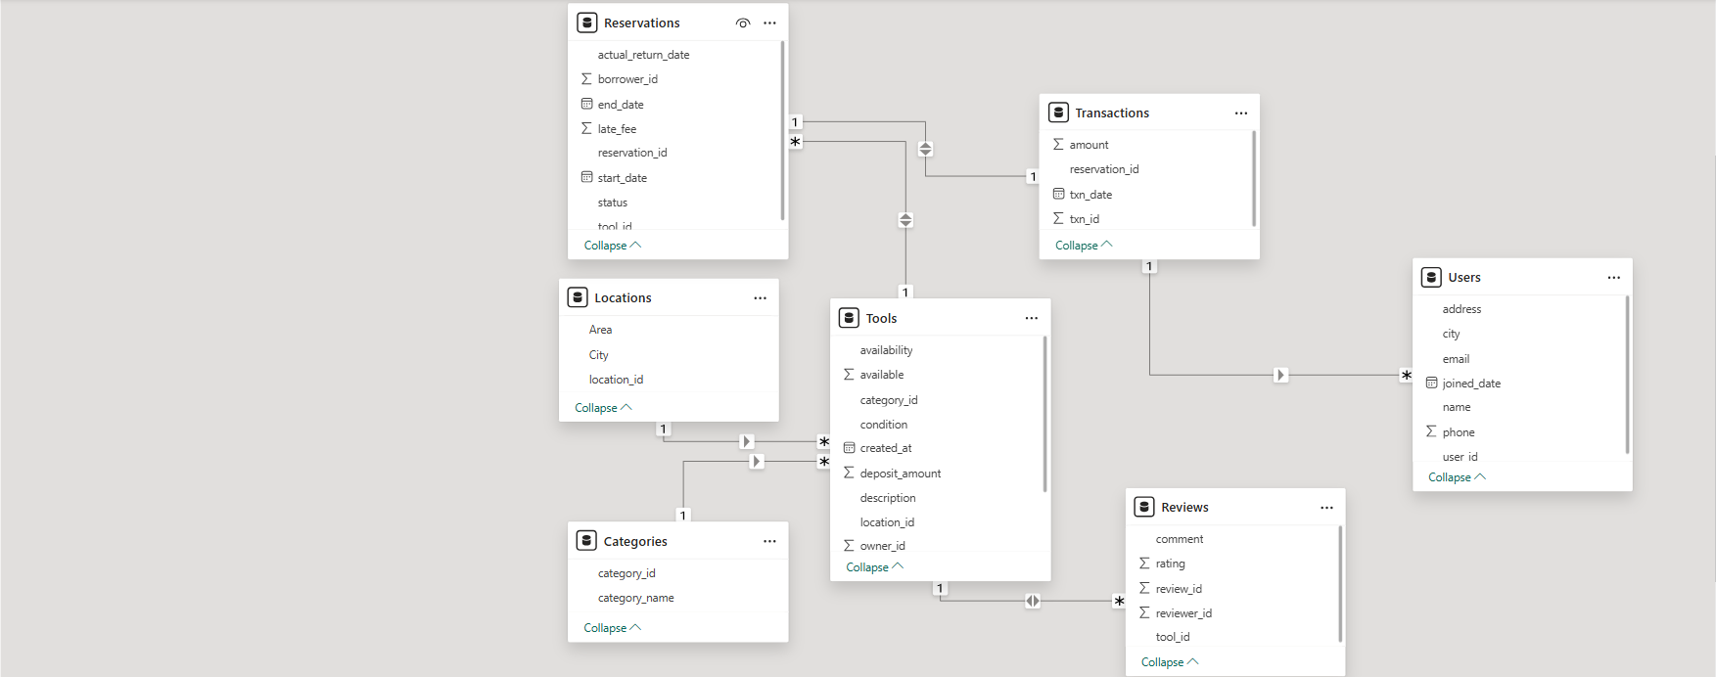Key Relationships
- Supports fast DAX performance
- Clean star schema
- No bi-directional or circular relationships
- Accurate filtering across pages
- Consistent KPI interaction
Why This Model Works
- Follows best Power BI modeling practices
- Slicers update visuals correctly
- No circular or redundant links
- Efficient DAX performance
- Supports clean multi-page reporting

SQL WORK DONE

Joins across 7 tables

Missing values detection

Duplicate removal

Data validation

Exported master table for Power BI

All keys verified (FK relations)

PROJECT WORKFLOW (STEP-BY-STEP)
STEP 1 — SQL Analysis
Performed:
- Inner joins, left joins
- Group by (category, city, rating, condition)
- Aggregations
- Missing data checks
- Exported final cleaned tables

STEP 2 — Python Data Cleaning
Performed using Pandas:
- Dropped null/duplicate values
- Standardized date fields
- Removed formatting issues
- Merged dataset files
- Exported cleaned CSV (final dataset used in Power BI)

STEP 3 — Power BI Dashboard
A 5-Page Professional Multi-Dashboard created:

📄 PAGE 1 — OVERVIEW DASHBOARD
🎯 Purpose:
Overall business summary at a glance.
📊 KPI Cards:
Total Users, Total Tools, Total Reservations, Total Amount, Count of Status
📊 Visuals:
• Bar Chart: Count of Tools by City
• Pie Chart: Count of Reviews by Rating
• Bar Chart: Count of Reservations by City
• Area Chart: Total Amount by Year
• Donut Chart: Amount by Status
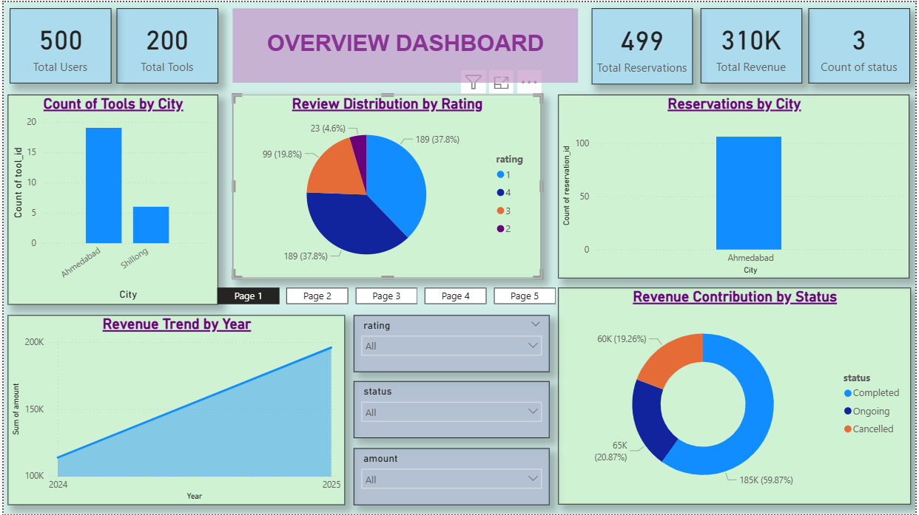
This dashboard summarizes key business performance metrics at a glance including Users, Tools, Reservations, Revenue, and Rating distributions. It helps leadership quickly assess current business status.

📄 PAGE 2 — CATEGORY-WISE TOOLS & CONDITION OVERVIEW
🎯 Purpose:
Detailed analysis of tools, categories, and reservation patterns.
This page helps understand customer demand and which tools/categories perform best.
📊 KPI Cards:
Total Categories, Total Reservations, Total Tools, Active Tools, Reservation Status Count
📊 Visuals:
• Bar Chart: Count of Tools by Category
• Donut Chart: Count of Reservations by Status
• Stacked Column Chart: Reservations by Category
• Bar Chart: Count of Tools by Availability
• Table: Tool List with Price, Status, Category
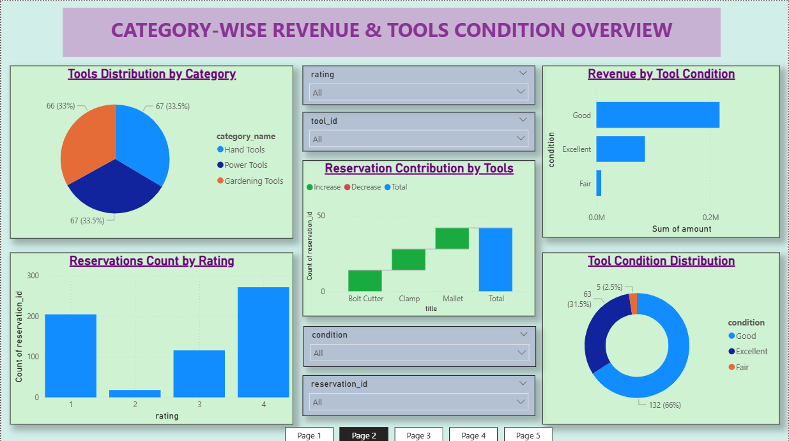

📄 PAGE 3 — CUSTOMER SATISFACTION & LOCATION ANALYSIS
🎯 Purpose:
Analyze customer reviews, ratings, city-wise performance, and tool distribution.
This page highlights customer satisfaction trends and identifies top-performing locations.
📊 KPI Cards:
Total Reviews, Avg Rating, Total Cities, Total Tools in Cities, Transactions Count
📊 Visuals:
• Donut Chart: Count of Reviews by Rating
• Filled Map: Sum of Amount by City
• Line Chart: Count of Transactions by Year
• Symbol Map: Tools Available by City
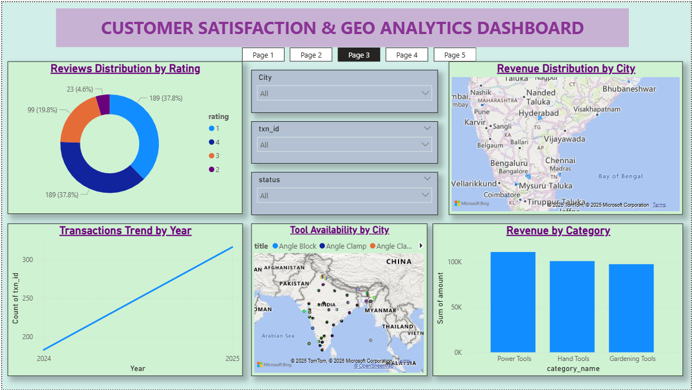

📄 PAGE 4 — FINANCIAL & OPERATIONS DASHBOARD
🎯 Purpose:
Track business earnings, payment trends, and year-wise financial growth.
This page supports revenue monitoring and helps identify peak earning periods.
📊 KPI Cards:
Total Amount, Total Transactions, Avg Transaction Amount, Paid Status Count, Pending Status Count.
📊 Visuals:
• Column Chart: Total Amount by Month
• Donut Chart: Amount by Payment Status
• Line Chart: Amount by Year
• Bar Chart: Transactions by Tool
• Table: Transaction Details (Tool, User, Amount, Status)
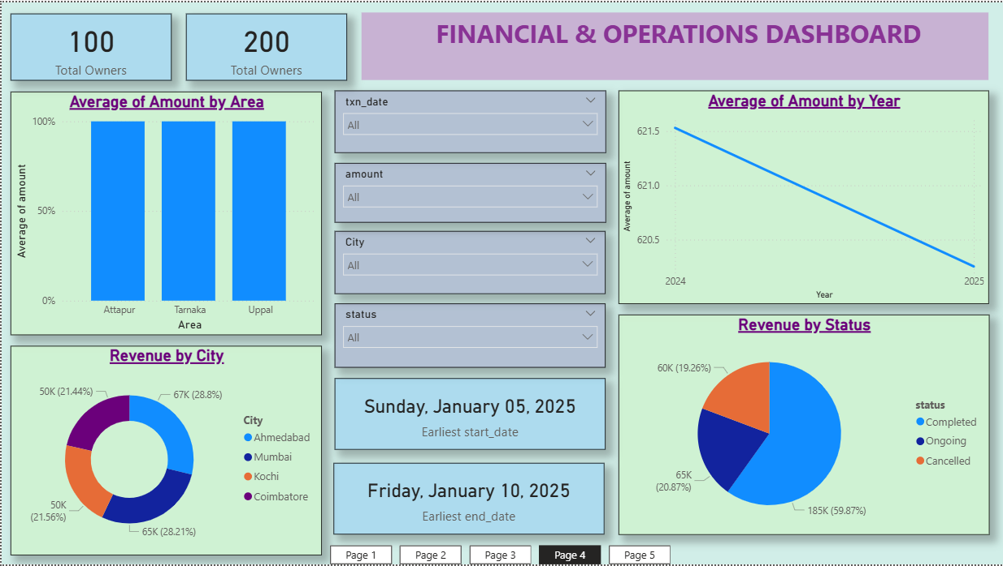

📄PAGE 5 — ADVANCED INSIGHTS & TREND ANALYSIS
🎯 Purpose:
Monitor user demographics, activity levels, and tool availability across locations.
This page helps understand user base strength and operational efficiency.
📊 KPI Cards:
Total Users, Active Users, Total Locations, Users by City, Tools by Location
📊 Visuals:
• Bar Chart: Count of Users by City
• Donut Chart: User Type Distribution
• Bar Chart: Tools by Location
• Map: Users Distribution by City
• Table: User List (Name, City, Type)
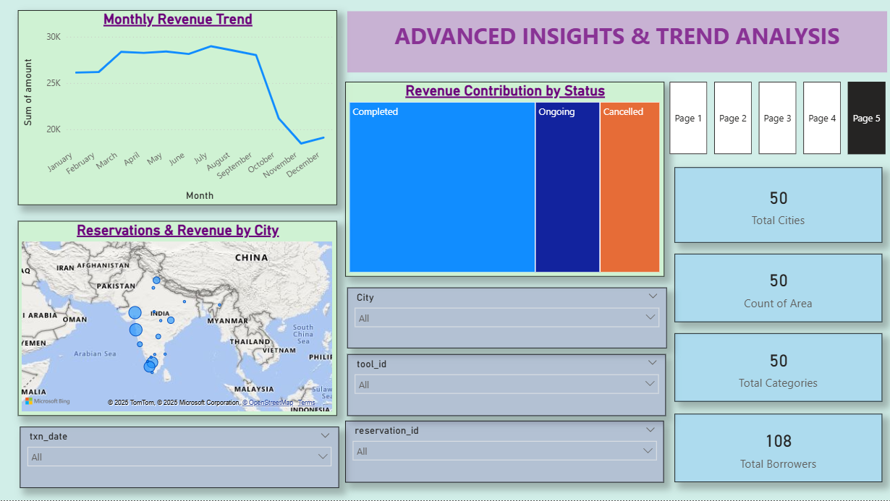

KEY INSIGHTS (BUSINESS FINDINGS)
🔥 Top Insights:
- Majority of tools fall under Good or Very Good condition.
- 5-star ratings dominate—customer satisfaction is high.
- Most reservations occur in specific months (seasonal trend).
- Drilling tools have highest booking frequency.
- Revenue is strongly driven by tool condition & category.
- A few categories contribute 60–70% revenue (Pareto effect).
- Some cities have high users but low bookings → engagement issue.
- Amount by status shows Completed drives most income.
- Average yearly revenue shows an increasing trend.

BUSINESS QUESTIONS ANSWERED IN THIS PROJECT
- Which cities generate the highest revenue?
- What tool categories perform best?
- How does customer satisfaction impact bookings?
- What months have the highest rental volume?
- How is financial growth improving year-over-year?

CONCLUSION
This analytical project helps the Neighborhood Tools business:
- Improve inventory management
- Focus on high-performing categories
- Improve tool conditions
- Expand into high-revenue cities
- Increase engagement in low-performing areas
- Make decisions based on customer ratings & demand patterns
- Power BI dashboards provide real-time insights for business teams.

PROJECT DELIVERABLES
- Cleaned CSV Dataset
- SQL Script
- Power BI PBIX File
- Documentation (this file)
- Insights Report

FUTURE ENHANCEMENTS
- Predictive forecasting
- Recommendation system for tools
- Customer segmentation using clustering
- Tool lifetime analysis
- Forecasting revenue
- Predicting tool demand
- Tool recommendation engine
- Customer segmentation using ML
- Tool lifecycle prediction
- Automated anomaly detection

